Practical - 10
Practical Title: Secure Login/Logout with Sessions, Role-Based Access, Timeout, and Remember-Me Token
Problem Definition : Develop secure login and logout functionality using PHP sessions. Verify password using password_verify(), regenerate session ID after login, restrict dashboard access, implement role-based redirection, session timeout, and optional secure remember-me token.
- Are sessions started and destroyed securely?
Answer: Yes. session_start() is called at the top of every protected page. After a successful login, session_regenerate_id(true) creates a new session ID to prevent session fixation. On logout, the session variables are cleared with session_unset(), the session is destroyed with session_destroy(), the session cookie is expired, and the user is redirected to the login page.
- Is password_verify() used correctly?
Answer: Yes. The user is first found by email, and the stored hash is fetched from the database. The entered password is then compared using password_verify($enteredPassword, $storedHash). The password is never compared directly or re-hashed manually. If verification fails, a generic message such as “Invalid email or password” is shown so attackers cannot tell which one was wrong.
- Is unauthorized dashboard access blocked?
Answer: Yes. Every dashboard page begins with a check on whether $_SESSION[‘user_id’] is set. If it is not, the user is redirected to the login page and the page stops with exit(). So typing the dashboard URL directly in the browser without logging in does not work.
- Is session timeout implemented?
Answer: Yes. The time of the user’s last activity is stored in $_SESSION[‘last_activity’]. On each request the script compares it with the current time. If the user has been inactive longer than the allowed limit (for example 15 or 30 minutes), the session is destroyed and the user is sent to the login page with a “Session expired” message. Otherwise the timestamp is refreshed.
- Are admin and student users redirected to appropriate dashboards?
Answer: Yes. The user’s role is stored in the session at login. After login, an admin is redirected to the admin dashboard and a student to the student dashboard. Each dashboard also checks the role, so a student cannot open admin pages by typing the URL.

C. Evidence of Work (Screenshots)

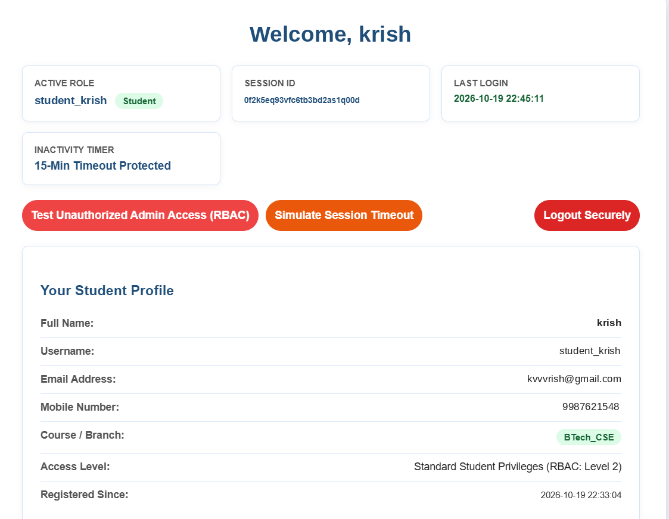

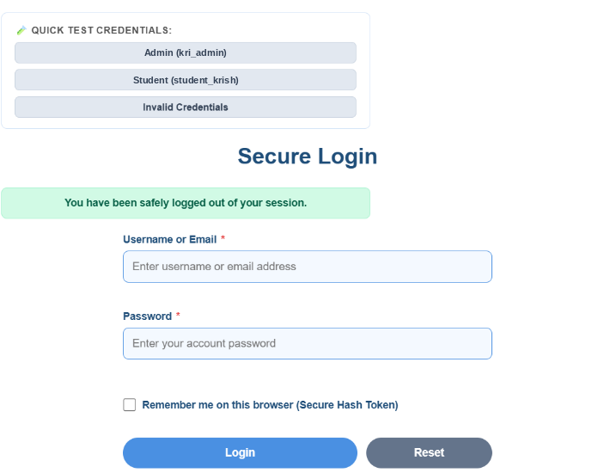

D. GitHub Repository Link :

https://github.com/kvvaghasiya49/Web_Development.git

E. Challenges Faced:
- Understanding the session lifecycle and why session_regenerate_id() is needed after login.
- “Headers already sent” errors caused by output or whitespace before header() redirects or session_start().
- Implementing the timeout logic correctly so that it works on every protected page.

F. Learning Outcomes:
- I can build secure login and logout functionality using PHP sessions.
- I can verify passwords using password_verify() and protect against session fixation.
- I can restrict page access and implement role-based redirection and access control.

G. Faculty Remarks:

